Game Document

1：The basic information
Name：Run Sheep
Platform: html game
The age of player: all
The data of release：2017.4.24
The development environment ：Cocoscreater+js

2：overview
Story:
Based on the outline of the story in the single page instruction, to add more to the story details, but not too long, cause, process and result made clear of the story.Little sheep happy play in the grasslands, there is the blue sky white clouds, the most important thing is that little sheep love grass is here. Grasslands, of course, there are many damned stone, can let the lamb tumble.
Description of the process:
a) start
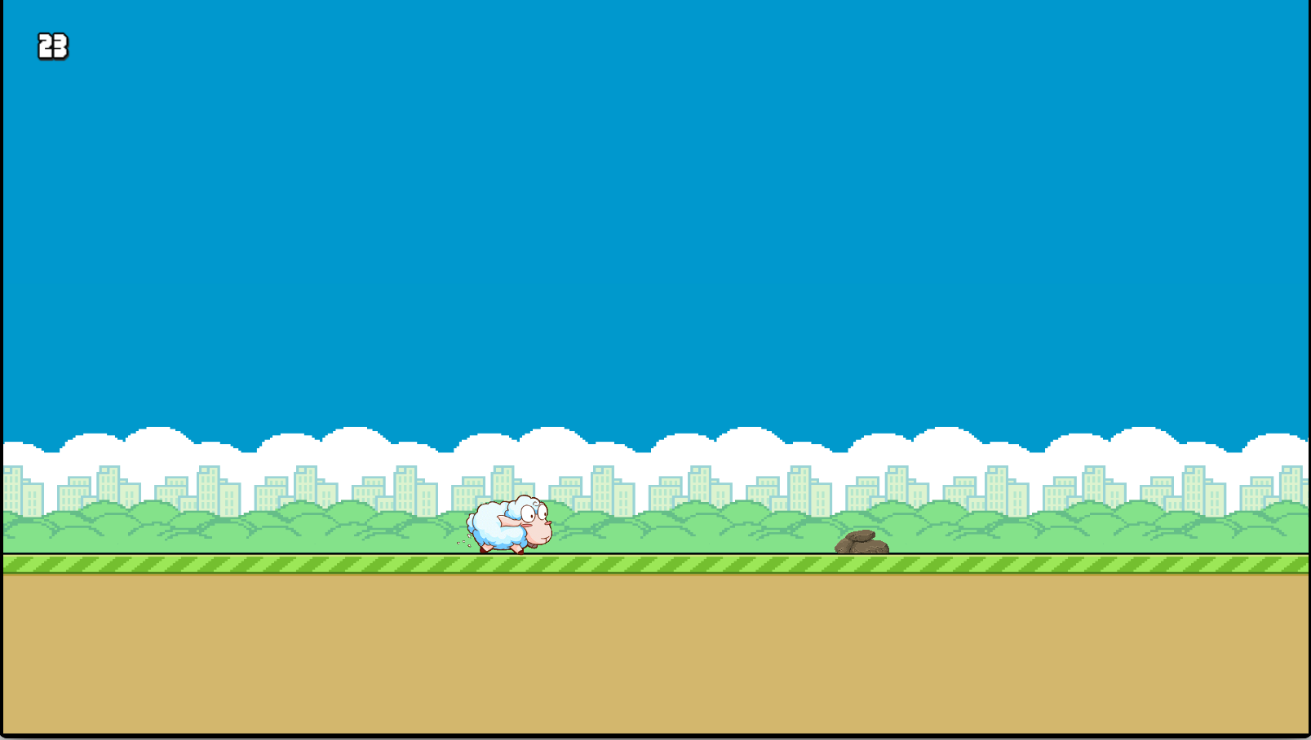
b)running
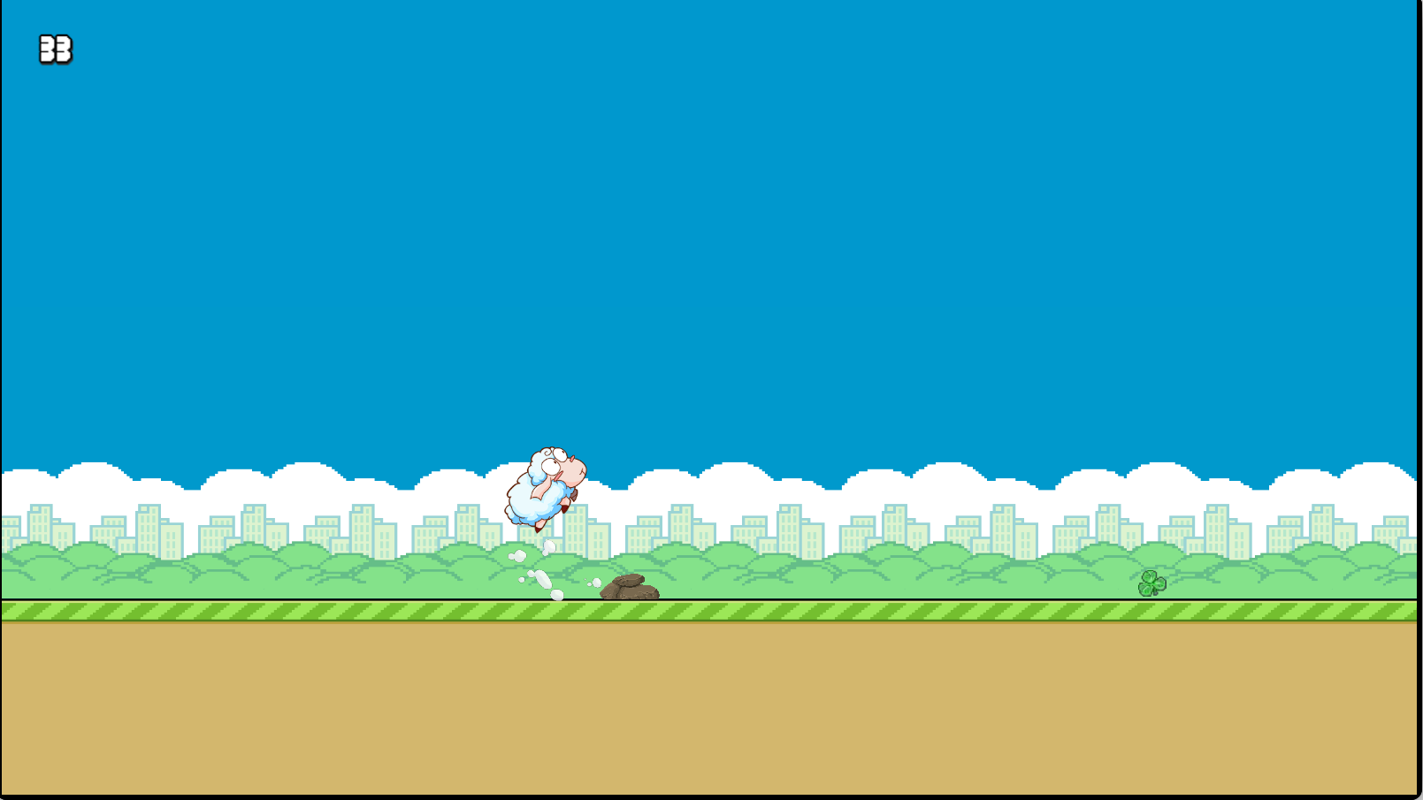
c)end
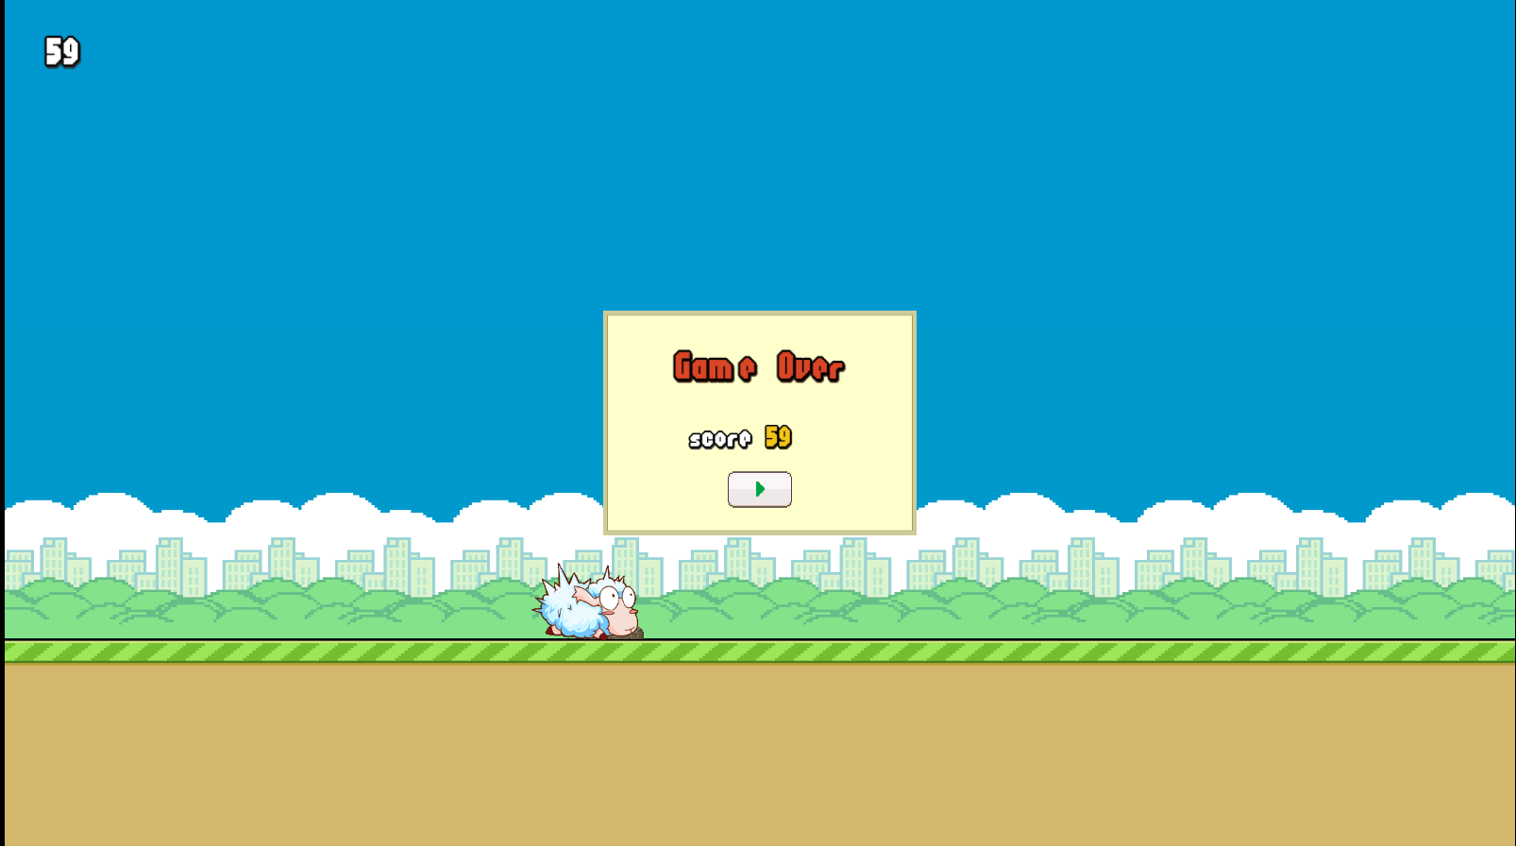
3: actor
background
According to the story background, provides some features about the player role: age, gender, and other game related properties.
The game role: small sheep can jump:


the story of the actor
Based on pleasant goat and Wolffy, Wolffy behind crazy chase, in order to escape the clutches of Wolffy, lamb must run to jump.
Little sheep goes well with green hills and water, plump body and short limbs and agile action form bright contrast.Let a person fondle admiringly.

4： playability

How to play:
According to the position of the little sheep, include the tap spacebar or let little sheep jumping the phone's screen, once hit stone, game over, by eating grass, can speed up the lambs, but speed is not evaluation standard, little sheep running distance is the sole criterion for evaluation of this game.
5：game experience
Games began, with the emergence of the background, has been little sheep in the picture. With relaxed and cheerful music player to bring relaxation and leisure. Here, the choice of the game sound is very important. We screened a lot of background music and finally decided to use the first ones with background music, believe that will let players stop. Game operation flow chart

6：Game authority
No organ, the most important rules of the game is to increase in the number of sheep are eating grass, the speed of the lamb will ascend.

